Cairo University  
Faculty of Computers and Artificial Intelligent

**CS251**

**Software Engineering I**

Project Name

Software Design

Team Names

|  |  |  |  |
| --- | --- | --- | --- |
| **ID** | **Name** | **Email** | **Mobile** |
| 20200603 | Noor El Deen Nizar | noornizaredu@gmail.com | 01009152050 |
| 20200279 | Abdelrahman Ahmed Ali |  |  |
| 20210612 | Omar Hussien Ibrahem |  |  |
| 20200838 | Abdelrahman Hesham | abdelrahmanhesham601@gmail.com | 01157428087 |

Month & Year:

8/5/2022

Contents

Instructions [To be removed] 3

Team 3

Document Purpose and Audience 3

System Models 3

I. Class diagrams 3

Important Algorithm 4

II. Sequence diagrams 5

Class - Sequence Usage Table 6

Ownership Report 6

Policy Regarding Plagiarism: 7

# Team

|  |  |  |  |
| --- | --- | --- | --- |
| **ID** | **Name** | **Email** | **Mobile** |
| 20200603 | Noor El Deen Nizar | noornizaredu@gmail.com | 01009152050 |
| 20200279 | Abdelrahman Ahmed Ali |  |  |
| 20210612 | Omar Hussien Ibrahem |  |  |
| 20200838 | Abdelrahman Hesham | abdelrahmanhesham601@gmail.com | 01157428087 |

# Document Purpose and Audience

**The design of the parking lot will be defined in this paper. It includes details on the intended input, output, classes, and functions. At the conclusion of the text, detailed illustrations depict the interaction between the classes in order to achieve the specified criteria.**

# This Design Specification is to be used by Software Engineers and developers.

# System Models

## I. Class diagrams

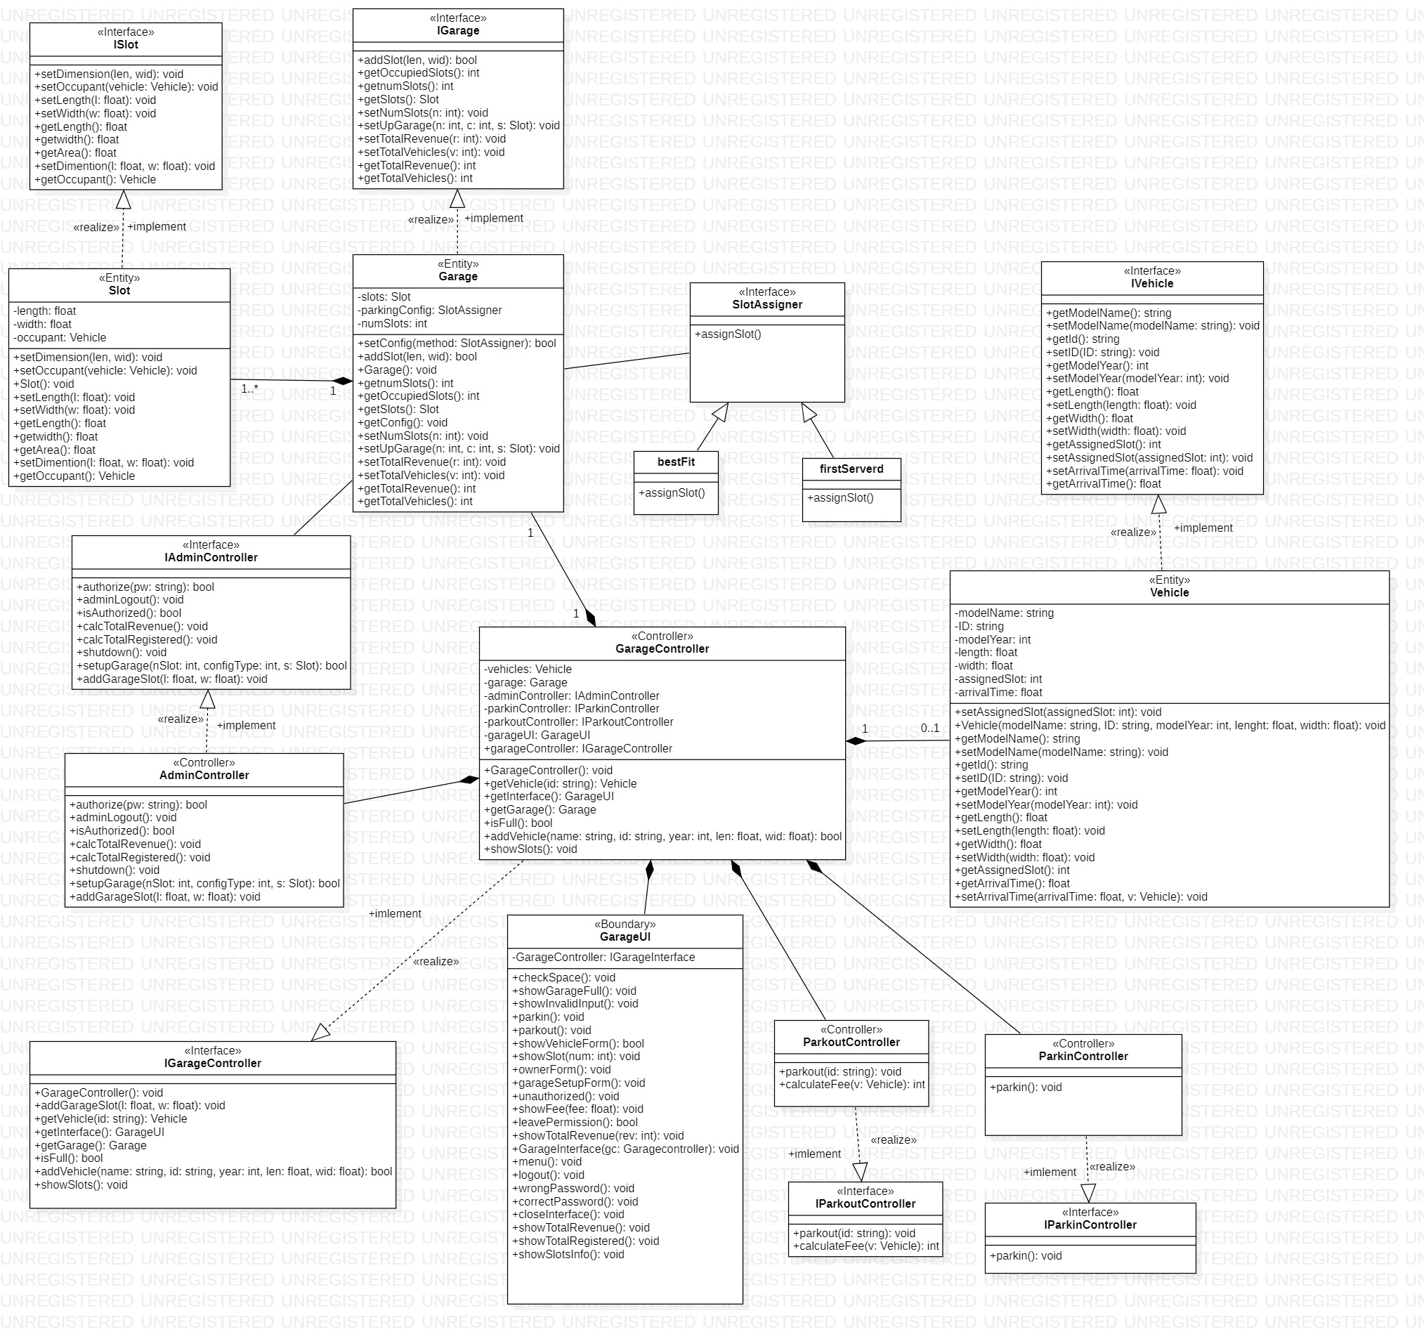

| **Class ID** | **Class Name** | **Description & Responsibility** |
| --- | --- | --- |
| 1 | Garage | Store slots and the configuration by which the parking lot will operate |
| 2 | Slot | Store Slots Dimensions and their occupation |
| 3 | vehicle | Store vehicle dimensions and the data about the vehicle |
| 4 | GarageController | Add vehicles and display slots ,check garage status |
| 5 | GarageUI | parked vehicles and any errors also the forms for submissions |
| 6 | AdminController | Controls all manager related functionalities |
| 7 | ParkinController | Manage parkin process |
| 8 | ParkoutController | Calculate fee and manage parkout process |
| 9 | SlotAssigner | Abstract class for the algorithms of the garage |
| 10 | bestFit | One of the algorithms for the garage setup (slot assigner) |
| 11 | FirstS | One of the algorithms for the garage setup (slot assigner) |

### Important Algorithm

## II. Sequence diagrams

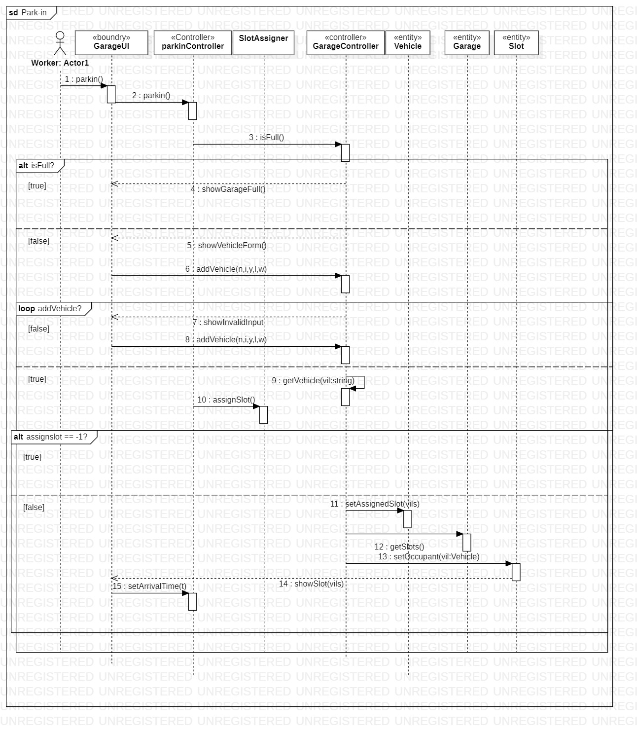

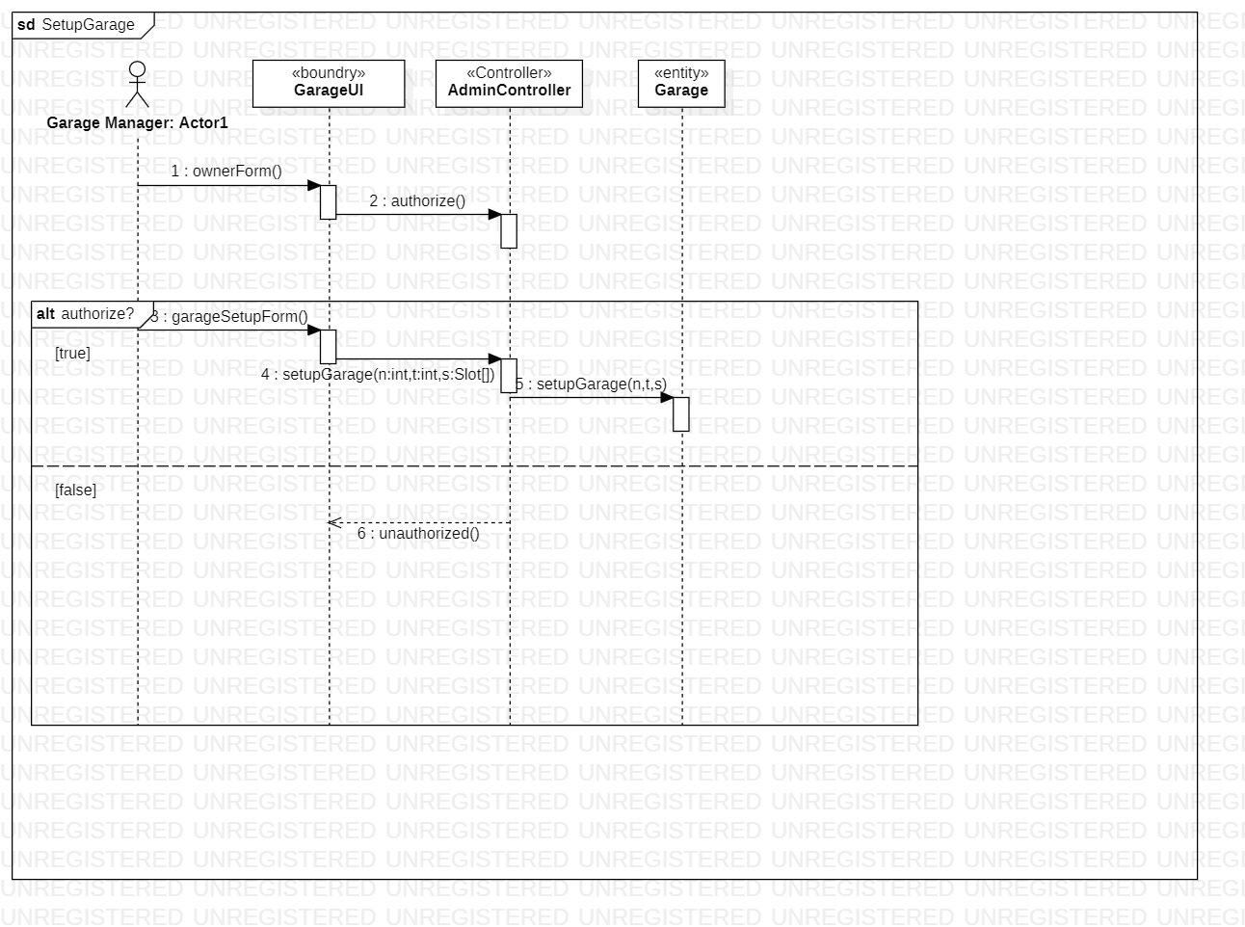

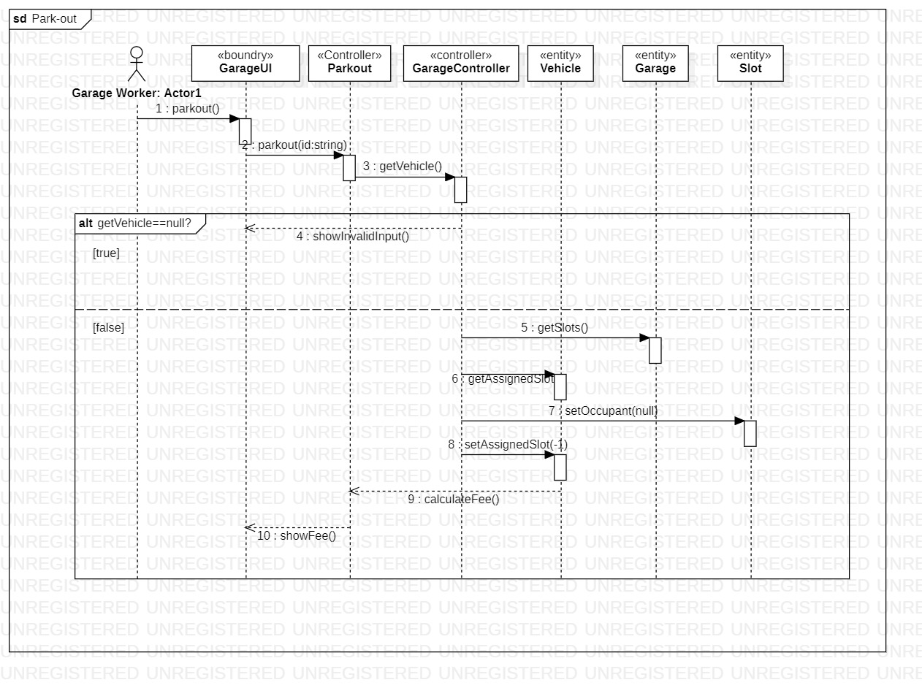

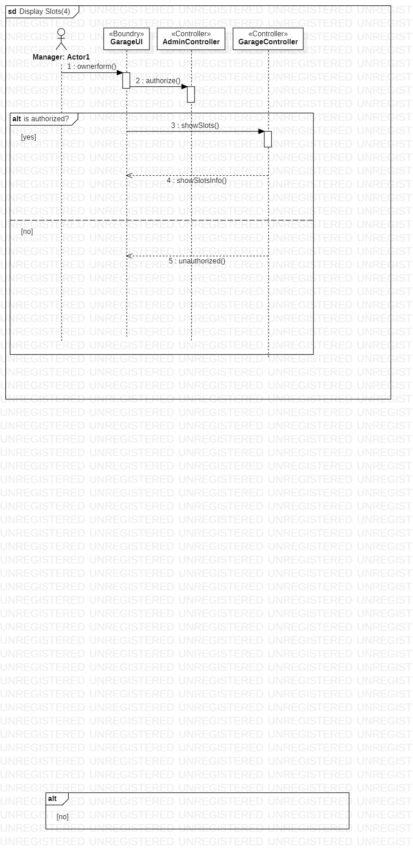

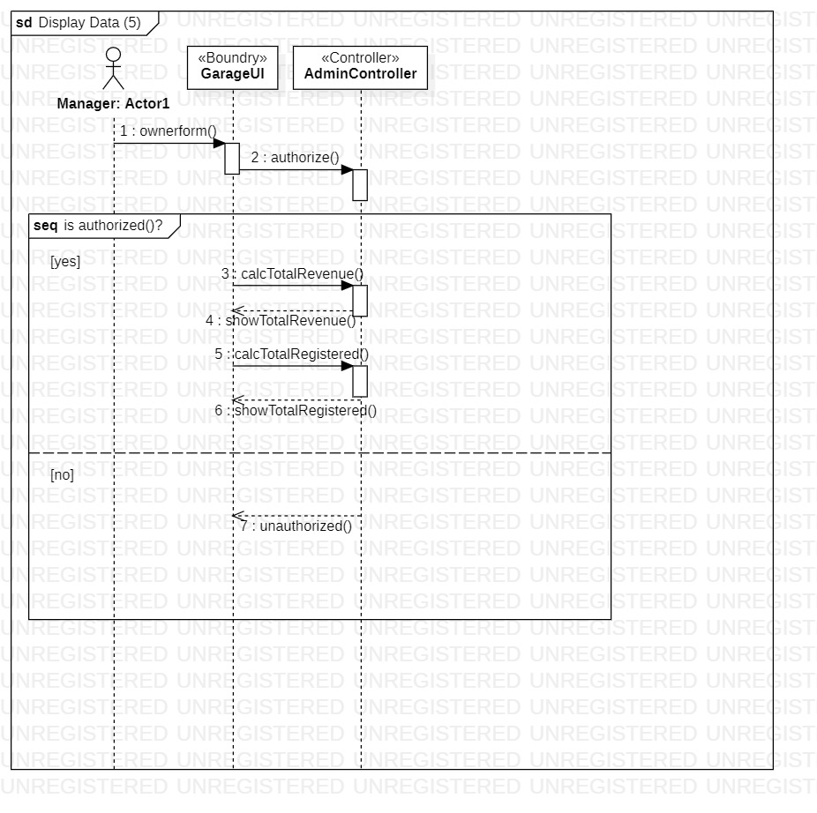

### Class - Sequence Usage Table

| **Class Name** | **Sequence Diagrams** | **Overall used methods** |
| --- | --- | --- |
| GarageUI | 1,2,3,4,5 | Parkin(),ownerform(),parkout(),showFee(),showInvalidInput()unauthorized(),showGarageFull(),showVehicleForm(),garageSetupForm(),showSlot(),showTotalrevnue(),showTotalRegistered(),showavailableSlots() |
| GarageController | 1,3,4 | addVehicle(n,I,y,l,w),getVehicle(),isFull(),displayAllAvailableSlots() |
| Garage | 1,2,3 | getSlots(),setupGarage(), |
| Vehicle | 1,3 | getAssignedSlot(),getOccupant(),setAssignedSlot(),setArrivalTime() |
| Slot | 1,3 | setOccupant() |
| ParkinController | 1 | Parkin(), |
| ParkoutController | 3 | Parkout(),calculateFee() |
| AdminController | 2,4,5 | Authorize(),setupgarage(),calcTotalFee() ,calcTotalRegistered() |

# Ownership Report

|  |  |
| --- | --- |
| **Item**  ***\**** | **Owners**  * |